Product category: AC DRIVES (VFD’s)

AC DRIVE COMPANY

DELTA

1. Model name: DELTA C2000 AC DRIVE

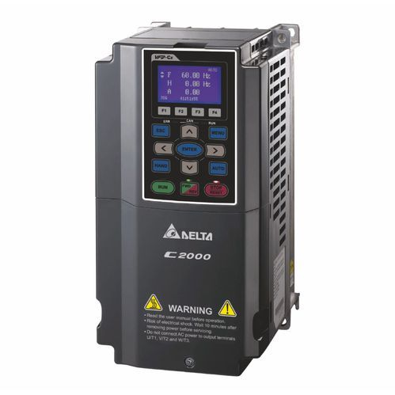

1. **MODEL NAME : DELTA MS300 INVERTER DRIVE**

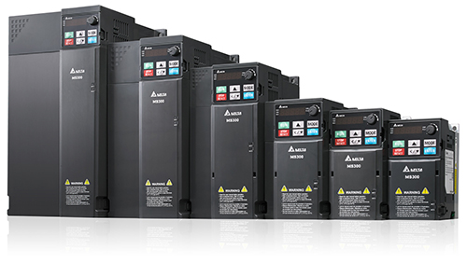

1. MODEL NAME: DELTA CP2000 INVERTER DRIVE

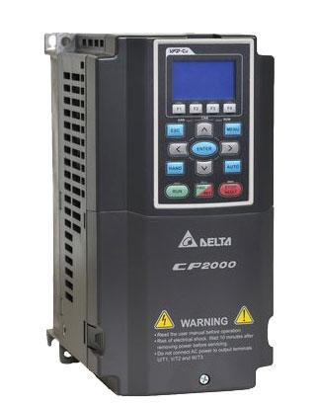

MODEL NAME: ALL OTHER DELTA VFD’S

The TP70P Series adopts a 65535 colors LCD touchscreen, supports Delta’s controllers, and can be connected to all series of Delta’s AC servo drives, AC motor drives, and temperature controllers. With four models providing different I/O configurations and supporting various output types, the TP70P Series’ high flexibility saves wiring cost and offers the best HMI and I/O control solution.

[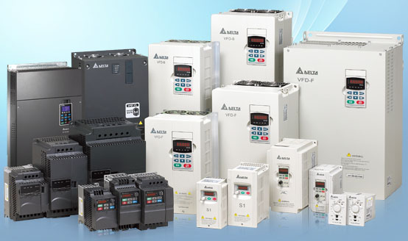](https://www.deltaelectronicsindia.com/industrial-automation/touch-panel-hmi-human-machine-interfaces/tp70p/" \o "TP70P)